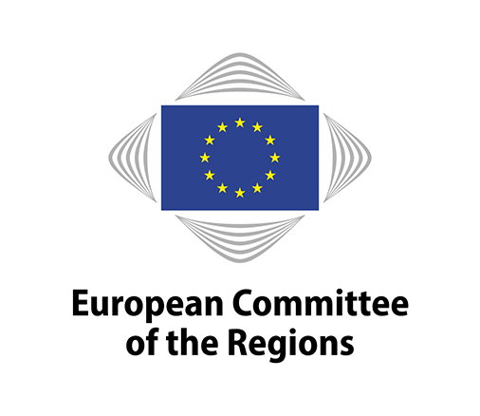
EN

DECLARATION OF THE CONFERENCE OF PRESIDENTS OF THE EUROPEAN COMMITTEE OF THE REGIONS
4 JULY 2023

TOWARDS THE EUROPEAN ELECTIONS IN 2024

REGIONS AND CITIES FOR A STRONGER, FAIRER
AND MORE DEMOCRATIC EUROPE

In less than a year, millions of voters across regions and cities in the European Union will be called on to vote in the 2024 European elections. Ensuring a high level of citizen participation will be crucial in shaping the future of the European Union.

The European Union's democracy is unique in bringing together three levels of government: local and regional, national and European. Therefore, all elected representatives must join forces and work together to address the challenges of our time with sustainable solutions, just as regions and cities have been doing with crises such as the COVID-19 pandemic, climate disasters, the energy crisis, demographic change and the welcoming of millions of refugees from Ukraine.

With over one million elected representatives at regional and local levels collectively responsible for 50% of public investment in the European Union, the electoral campaign, the negotiations for the 2024-2029 Strategic Agenda, the political priorities of the next legislative term of office and the next State of the Union address must recognise that a fundamental partnership with the EU's cities and regions is crucial to ensuring that EU policies deliver concrete results for our citizens and to strengthening the EU's democratic legitimacy.

Therefore, the Conference of Presidents of the European Committee of the Regions calls on all European political parties, their members at national and sub-national levels, their candidates to the European Parliament and lead candidates for the presidency of the European Commission, as well as on the EU and national leaders taking part in the campaign to pledge to:

Promote more territorial, social and economic cohesion and solidarity, including via an EU budget that is fit for purpose, while fully supporting a stronger cohesion policy, as this is the main EU investment policy to support all regions in achieving the green and digital transition; concretely addressing the need for simplification and measures to deliver lasting administrative capacity at local and regional level.

Strengthen partnerships with local and regional authorities, considering their high level of trust among citizens and the fact that 70% of EU legislation has a direct local and regional impact. They should therefore be more involved in shaping EU policies in line with the principle of active subsidiarity and the recommendations of the Conference on the Future of Europe.

Mobilise the more than one million elected local and regional representatives across Europe, to engage with citizens in local dialogues, involving young elected politicians and local and regional councillors, not only during the forthcoming campaign but also beyond, in elections at all levels in order to reinforce the citizens' democratic ownership.

By upholding these commitments, as well as the fundamental values and principles of the EU, we can ensure that the upcoming legislative term of the European institutions will be one where all regions and cities can make their voice heard and have a legitimate role to play, to the benefit of all citizens of the European Union.
_____________

The Conference of Presidents – chaired by the President of the European Committee of the Regions – brings together the leaders of each political group represented in the European Committee of the Regions (European People's Party, Party of European Socialists, Renew Europe, European Conservatives and Reformists, European Alliance and the Greens), as well as the First Vice-President.

